A Comparison of eDNA Detections to Concurrent Visual Observations of Marine Mammals

Methods:

    - Marine mammal detection comparison with concurrent visual surveys
As marine mammals are one class of rare marine vertebrates with ongoing concurrent monitoring effort on CalCOFI, we compared the eDNA results for the two research cruises with concurrent marine mammal visual observation records (anonymized visual observer protocol available in supplement, DOI provided for publication). We calculated the number of days on which marine mammals were detected with each eDNA sampling method and visual observations. The proportions of mammal-positive survey-days per method were compared to each other using Fisher’s exact test for small sample sizes (N<10 or detections<5) or two-proportion z-tests for larger sample sizes. P-values were corrected for multiple testing for the 10 comparisons using the Holm-Bonferroni sequential correction procedure. We then filtered all visual observations and eDNA detections to only marine mammals identified to species-level with phyloseq (v.1.48.0) (McMurdie & Holmes, 2013) before visualizing overlap in species detected by each method with a venn diagram. For this overlap analysis, Delphinus capensis (long-beaked common dolphin) occurrences recorded by visual observers and Delphinus bairdii (Eastern North Pacific long-beaked common dolphin) detected by eDNA analysis were considered the same species as these names both refer to the single long-beaked sub-species of common dolphin (D. delphis bairdii) occurring in the region (Jefferson et al., 2024; Urrutia-Osorio et al., 2025).

Results:
Comparison of MOSAIC eDNA to marine mammal visual survey detections by survey-day
Concurrent visual surveys conducted on the same research cruises detected marine mammals on 18 (60%) of the 30 days, whereas MOSAIC-A detected marine mammals on 100% of the survey-days, MOSAIC-B detected marine mammals on 100% of the 7 days on which it was employed, MOSAIC-C detected marine mammals on 5 (83.3%) of the 6 survey days it was used, and CTD samples detected marine mammal eDNA on 7 (46.7%) of the 15 days that CTD sampling occurred. The MOSAIC-A method detected marine mammals on significantly more ship-days than did the visual survey method (two-proportion z-test, p=0.003) or the CTD method (two-proportion z-test, p<0.001).
The MOSAIC-A full transect direct filtration method detected 16 marine mammal species, including all of the marine mammals that the other eDNA methods detected, and an additional 5 unique taxa (Fig. S1). Visual surveys made 8 species-level identifications of marine mammals, two of which, Delphinus delphis (short-beaked common dolphin), and Lagenorhynchus obliquidens (Pacific white-sided dolphin), were only detected by visual survey and were not detected in the eDNA samples. The unique taxa to the MOSAIC-A method were: Berardius bairdii (Baird’s beaked whale), Callorhinus ursinus (Northern fur seal), Kogia breviceps (pygmy sperm whale), Stenella longirostris (spinner dolphin), and Zalophus californianus (California sea lion). Visual surveys and MOSAIC-A samples shared two species that were not found in any other eDNA samples, Balaenoptera musculus (blue whale), and Grampus griseus (Risso’s dolphin). Marine mammal species unique to MOSAIC-A and B methods were Arctocephalus townsendi (Guadalupe fur seal) and Mirounga angustirostris (Northern elephant seal). The species detection shared by all eDNA methods and the visual survey was Delphinus capensis / Delphinus bairdii (Eastern Pacific long-beaked common dolphin).
Figure:
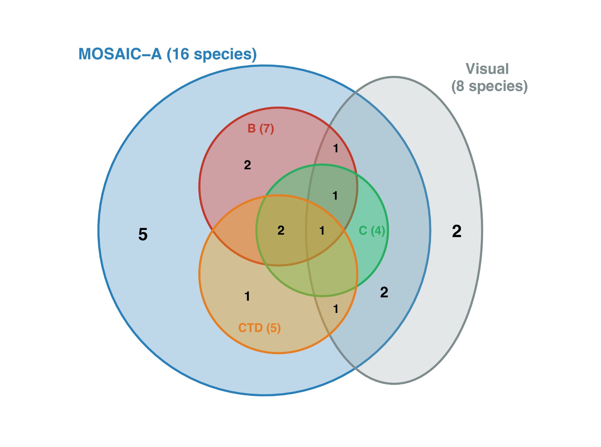Figure S1: A venn diagram showing the number of species of marine mammals detected by the four types of eDNA sampling methods and visual observations over the course of two CalCOFI research cruises. MOSAIC-A only (5): Berardius bairdii, Callorhinus ursinus, Kogia breviceps, Stenella longirostris, Zalophus californianus. MOSAIC-A and B only (2): Arctocephalus townsendi, Mirounga angustirostris. MOSAIC-A, B, and visual survey (1): Balaenoptera physalus. MOSAIC-A and CTD only (1): Balaenoptera acutorostrata. MOSAIC-A, B, C, and CTD (2): Orcinus orca, Stenella coeruleoalba. All eDNA methods and visual survey (1): Delphinus capensis / Delphinus bairdii. All methods except CTD (1): Tursiops truncatus. MOSAIC-A, CTD, and visual only (1): Megaptera novaeangliae. MOSAIC-A and visual only (2): Balaenoptera musculus, Grampus griseus. Visual only (2): Delphinus delphis, Lagenorhynchus obliquidens.

References:
Jefferson, T. A., Archer, F. I., & Robertson, K. M. (2024). The long-beaked common dolphin of the eastern Pacific Ocean: Taxonomic status and redescription of Delphinus bairdii. Marine Mammal Science, 40(4), e13133. https://doi.org/10.1111/mms.13133
McMurdie, P. J., & Holmes, S. (2013). phyloseq: An R Package for Reproducible Interactive Analysis and Graphics of Microbiome Census Data. PLoS ONE, 8(4), e61217. https://doi.org/10.1371/journal.pone.0061217
Urrutia-Osorio, M. F., Jefferson, T. A., Morin, P. A., Hancock-Hanser, B. L., McGowen, M., Becker, M. A., & Archer, F. I. (2025). Phylogenetic Relationships Among Eastern Pacific Common Dolphins (Delphinus spp.). Aquatic Mammals, 51(2), 144–153. https://doi.org/10.1578/AM.51.2.2025.144

